**Week 4**

**Hands on 2**

**Hello World RESTful Web Service** :

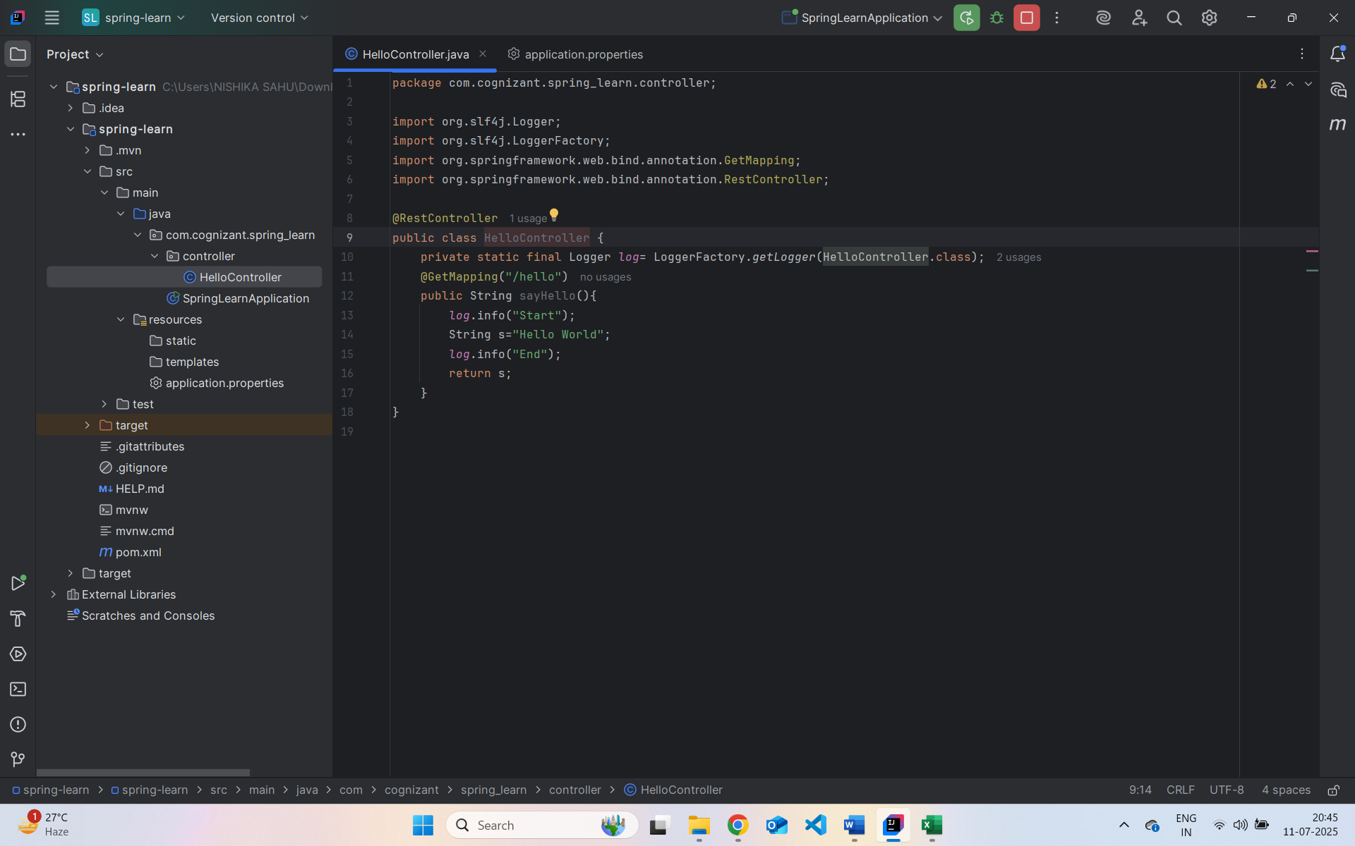

Output:

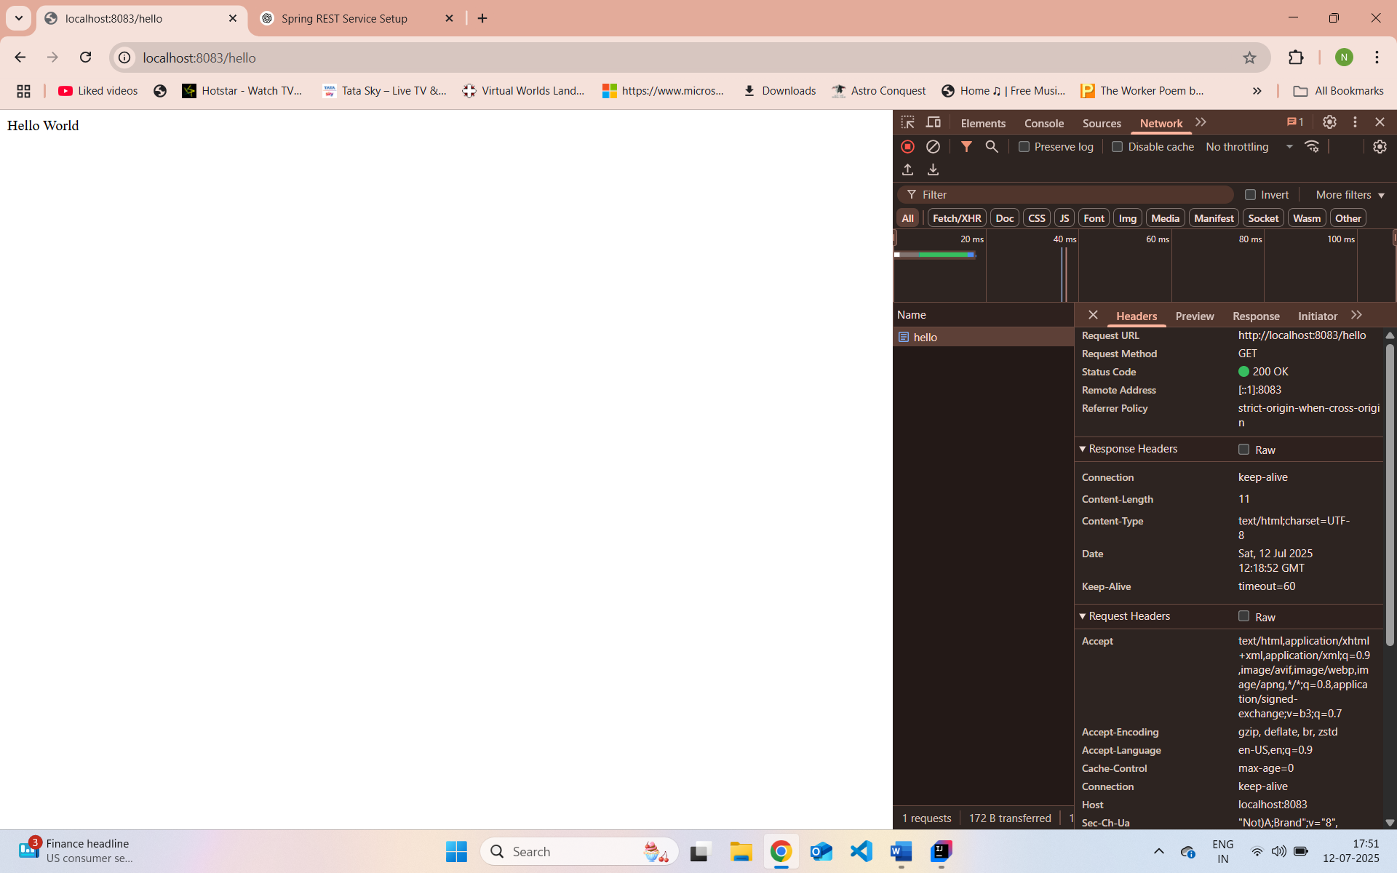

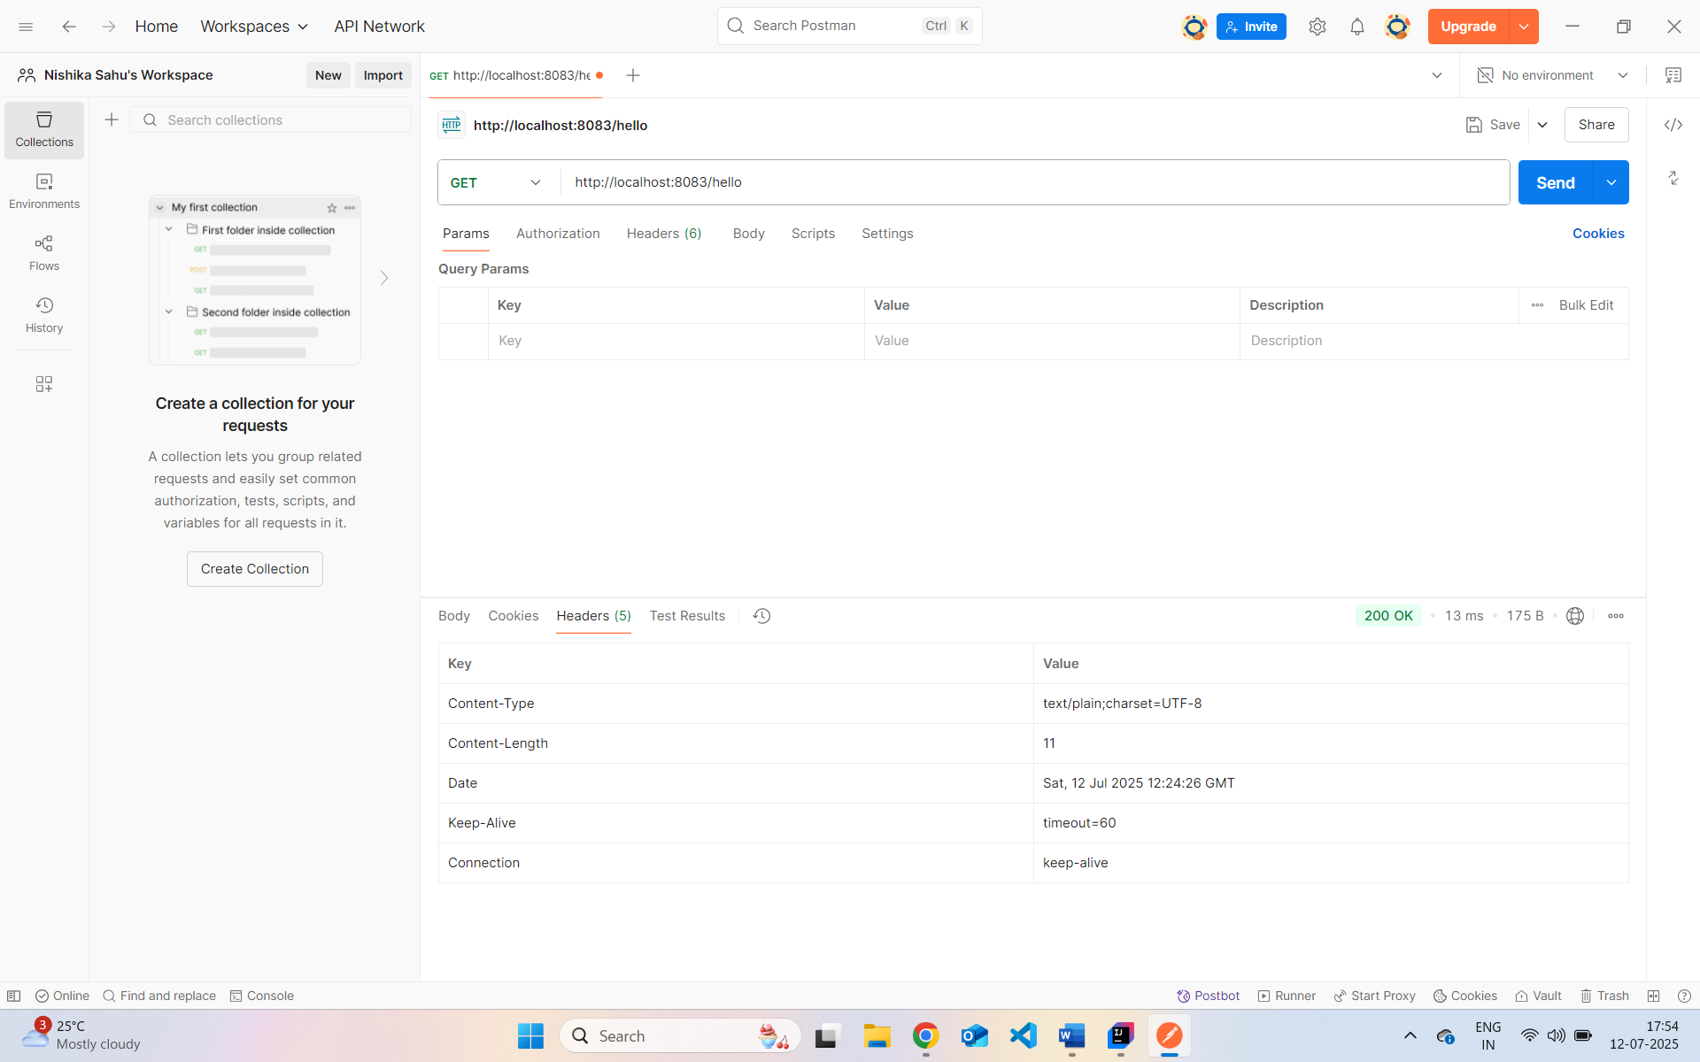

**REST - Country Web Service** :

com.cognizant.spring-learn.model.Country.java

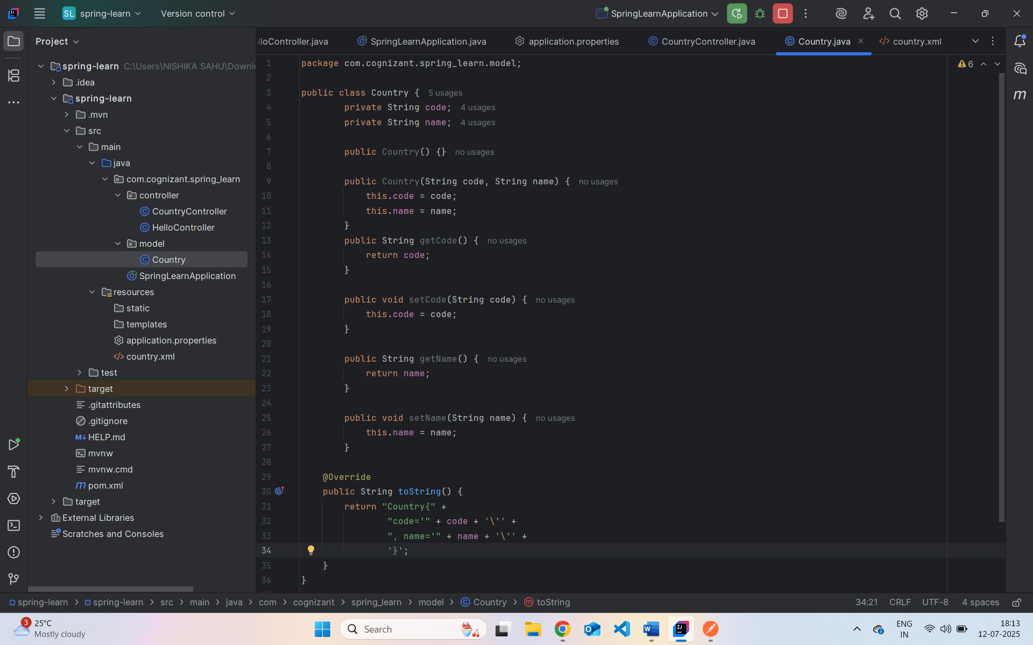

src/main/resources/country.xml

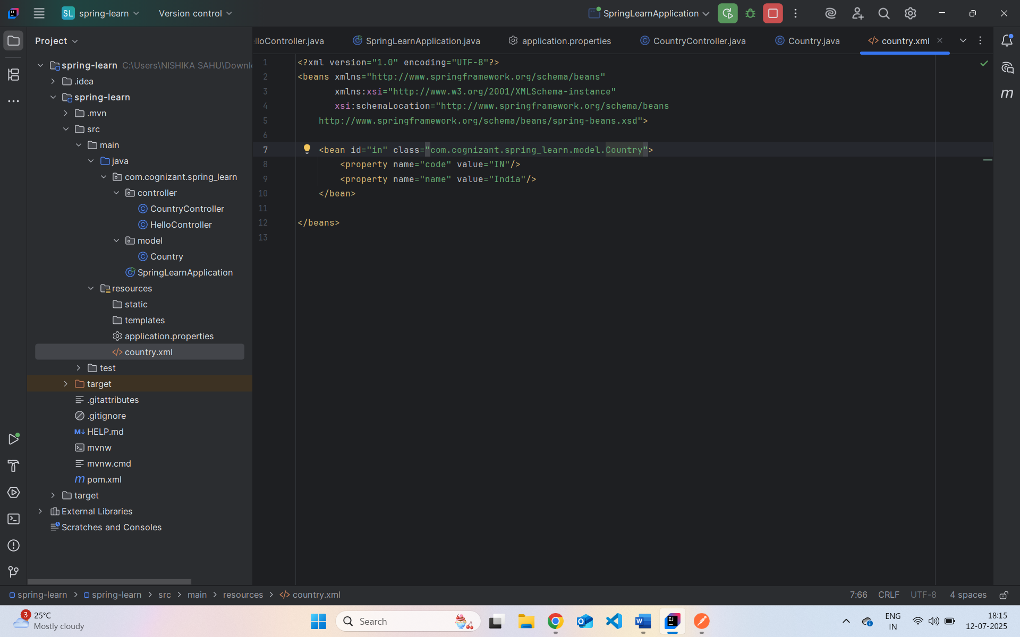

com.cognizant.spring-learn.controller.

**What happens in the controller method?**

1. A request to /country maps to the method getCountryIndia().
2. The Spring ApplicationContext loads the bean configuration from country.xml.
3. The in bean (India) is fetched and returned.

**How is the Java bean converted to JSON?**

* Spring Boot automatically uses **Jackson** (a JSON converter library).
* It detects that Country is a POJO and uses getters (getCode(), getName()) to convert it into a JSON response.
* This is done via @RestController, which combines @Controller and @ResponseBody, meaning return values are serialized directly to the response body (JSON by default).

In Chrome Developer Tools: 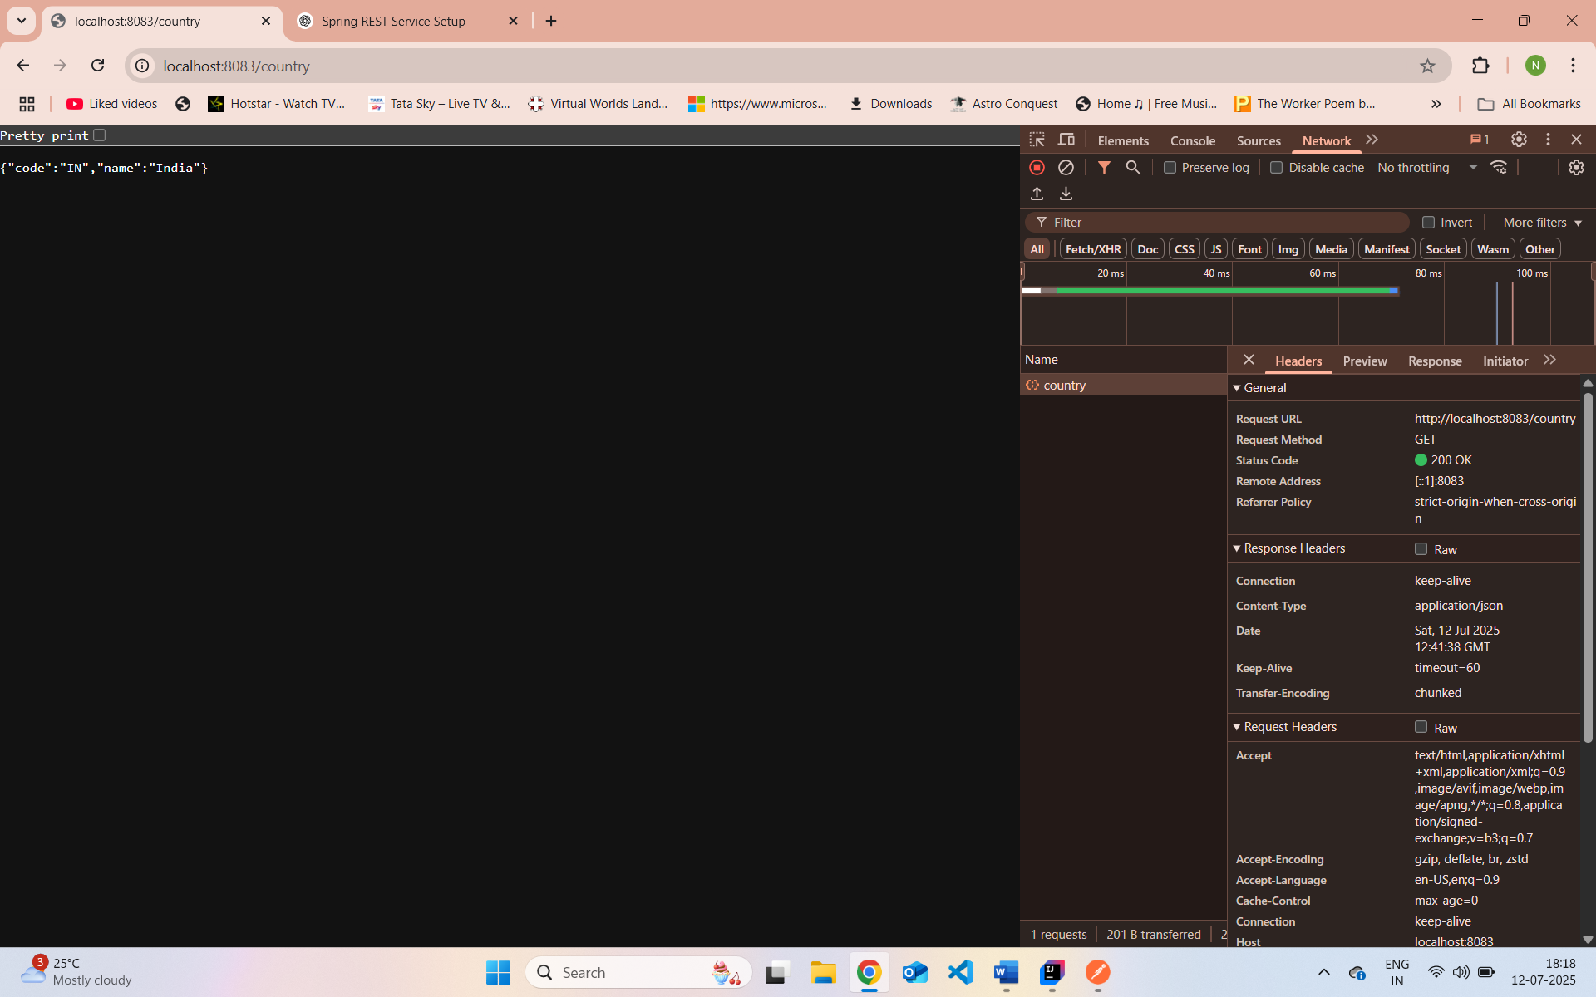

In Postman:

**REST - Get country based on country code** :

src/main/resources/country.xml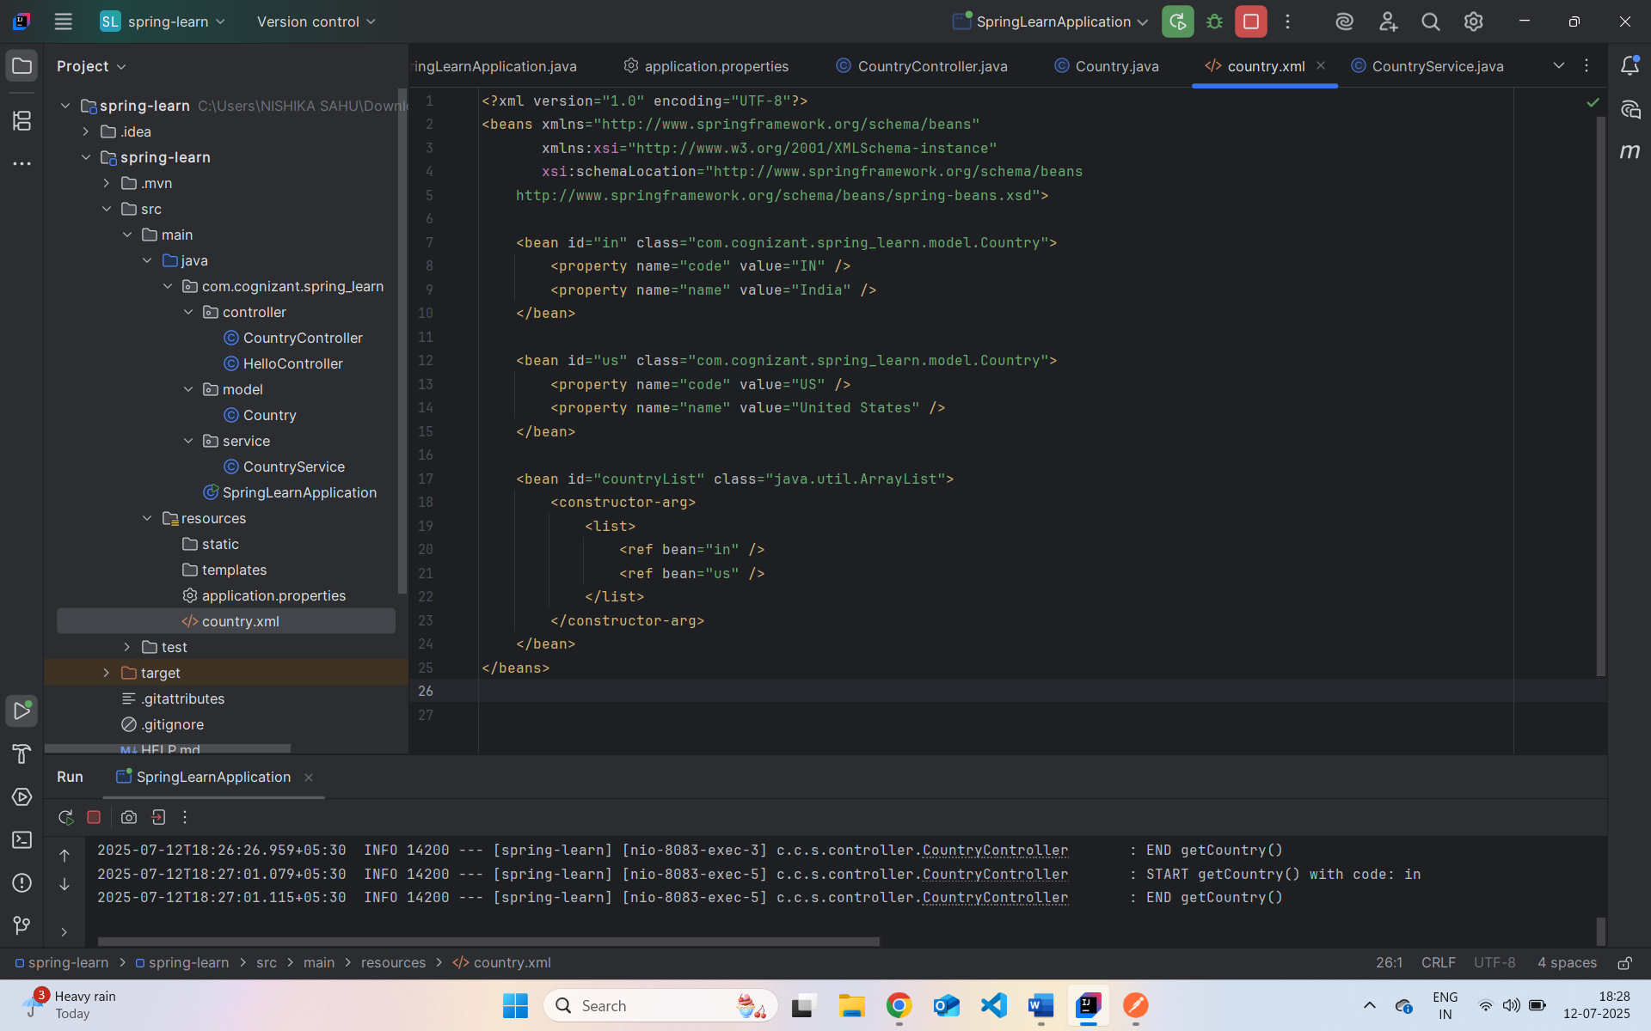

com.cognizant.spring_learn.service.

com.cognizant.spring_learn.controller.